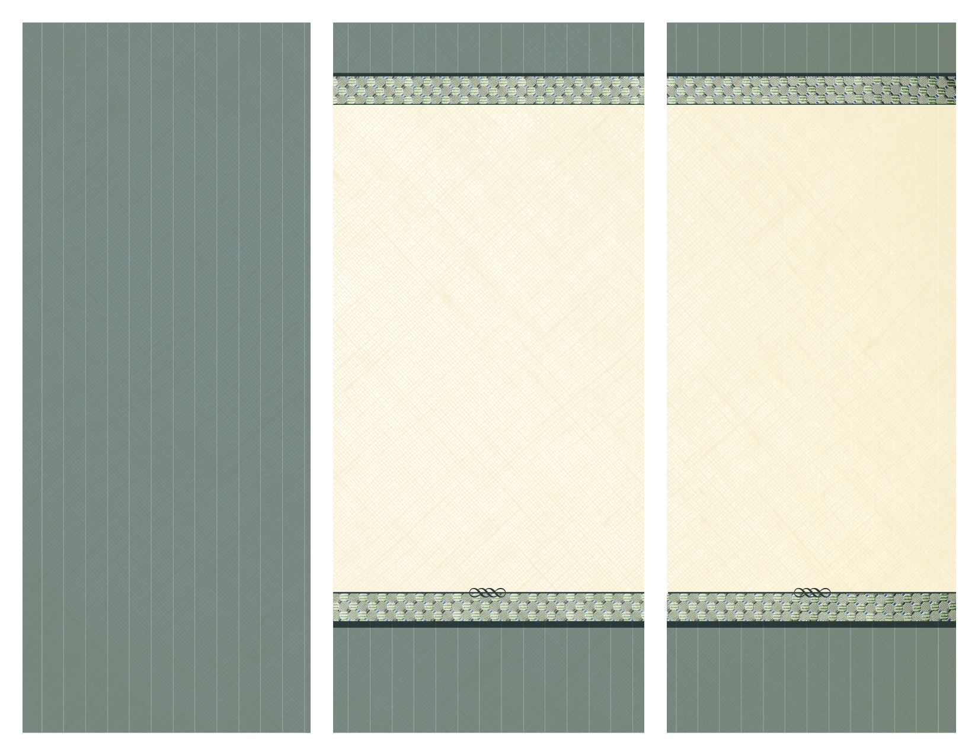

www.13documents.com is an online document filing system for debtor attorneys to submit documents to the Trustee’s office in electronic format prior to 341(a) and Confirmation Hearings.

**Amrane Cohen**  
Standing Chapter 13 Trustee

770 The City Drive South, Suite 8500  
Orange, CA 92868

714.621.0200 *phone* • 714.621.0277 *fax*

www.ch13ac.com

Getting Started with  
13documents.com

* **Documents must be in PDF format**
* **Optimize / shrink file size before uploading - document file size must be smaller than 10 MB**
* **ALWAYS upload multiple documents of the same type SEPARATELY and use the ‘Document Description’ box to indicate more information about the document**

**Examples:**

* + **Upload debtor / co-debtor proof of income separately and, in the ‘Document Description’ box, enter for which debtor the document applies and the type of income e.g.**
    - **Debtor – Wages OR**
    - **Co-Debtor – Social Security OR**
    - **Debtor – Disability**
  + **Upload tax returns for each year separately and enter the tax year in the document description**
* **It is recommended to wait 3 days after a case is filed before attempting to upload a document. Otherwise, you may receive an error indicating an invalid case number, when, in fact, it simply has not yet been imported into the Trustee’s database.**
* **DO NOT UPLOAD DOCUMENTS YOU ARE FILING IN THE CASE. Documents filed in the case are downloaded every night and available for viewing the next business day.**

Contact Harold Estrada at harold@ch13ac.com

**Amrane Cohen**  
Standing Chapter 13 Trustee

770 The City Drive South, Suite 8500  
Orange, CA 92868

714.621.0200 *phone* • 714.621.0277 *fax*

www.ch13ac.com

**HELPFUL HINTS  
TO MAKE DOCUMENT PROCESSING FAST AND ACCURATE**

NEED HELP?

1. Go to **www.13documents.com** and enter your USERNAME and PASSWORD.
2. Click the PROCEED TO DOCUMENT FILING button.
3. Select the appropriate Trustee and, if necessary, click the MAKE DEFAULT checkbox so you do not have to choose the Trustee at each login. Click the NEXT STEP button.
4. Enter the case number. DO NOT INCLUDE THE DASH (case number 8:15-10479-CB should be input as 1510479).
5. The case number will be validated against the Trustee’s caseload. If the case is not in the Trustee’s system you will get this message: “Case number is invalid. Please try again.” If the case validation is successful, the debtor(s) name(s) will be displayed. Please check the name before proceeding.
6. Select a document type from the drop-down menu.
7. Click the CHOOSE FILE button to navigate to the PDF file you wish to upload.
8. Click the UPLOAD FILE button.
9. A successful upload will direct you to a page asking for additional information about the document. In the text box provided indicate specific information about the document. See “HELPFUL HINTS” section for details.
10. Click the COMPLETE UPLOAD button.
11. A successful document submission will generate a document serial number. SAVE THIS NUMBER, as it is your proof of successful transmission.
12. Go to **www.13documents.com** and enter your USERNAME and PASSWORD.

***\*Your USERNAME is the email address   
you provided during registration\****

1. Click the link: “Request Trustee Upload Access”.
2. Choose the Trustee and click REQUEST ACCESS button. Only select those trustee offices you are going to be uploading documents to.
3. A successful request will generate this message “Successfully requested Trustee approval”.
4. If approved, you will receive an email within 2 business days.

You are now ready to begin   
uploading documents!

www.13documents.com

STEP 2: REQUEST UPLOAD  
PERMISSION

1. Go to **www.13documents.com** and click the link: “Click here if you are member of the debtor bar”.
2. Complete the basic information form and click the NEXT STEP button.
3. Complete the contact information form and click the COMPLETE button.
4. A successfully submitted form will generate this message: “Validation e-mail has been sent. Please check your e-mail.”

5. Click the link provided in the validation email OR copy and paste it into your browser to validate your registration request.

6. A successful account validation will direct you to a page requiring you to create a password. Enter a password, repeat the password and click the SUBMIT button.

***\*Passwords must be 6 – 14 characters long\****

7. Your account is active immediately after your password is accepted.

STEP 3: UPLOAD DOCUMENTS

STEP 1: REGISTRATION

***Make sure your SPAM filters are set to accept emails from www.13documents.com.***

***Add dnr@13documents.com to your   
SAFE SENDERS list.***